Big Mountain Data Analysis Recommendation Report

# First Look

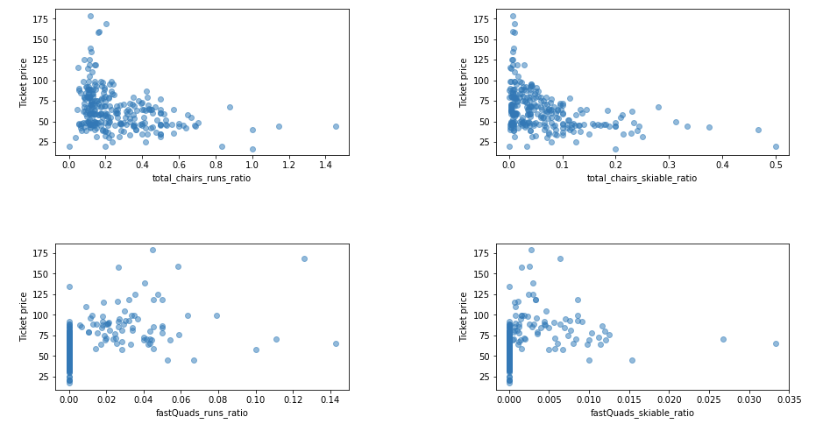After wrangling and cleaning our provided dataset we started out by looking for correlations between the dataset features and adult weekend ticket price. Simply looking at the scatter plot of some of the features with higher correlations provided some valuable insight right off the bat. We found that vertical drop, number of fast quads, number of total runs and total chairs had strong positive relationships with ticket price. We dug a bit further and plotted the total chairs/total runs, total chairs/skiable area, fast quads/total runs and fast quads/skiable area ratios and got the scatter plots below, in **figure 1**.

Figure – Scatter plots of feature ratios

These plots are worth noting due to the fact that with increases in feature relative to total number of runs, the ticket prices plummet and stay low. It is also worth noting that resorts with zero fast quads, have significantly lower ticket prices as well.

# The Data Model

We trained our data set using both linear regression and random forest regression models. We found the random forest model to have the lower mean absolute error, so this is the model we selected and base our recommendation off of. The top four parameters found using this model are as follows: fastQuads, Runs, Snow Making_ac and vertical_drop, in that order. **Figure 2**, below, shows the importance of all the dataset features in predicting ticket price using this model.

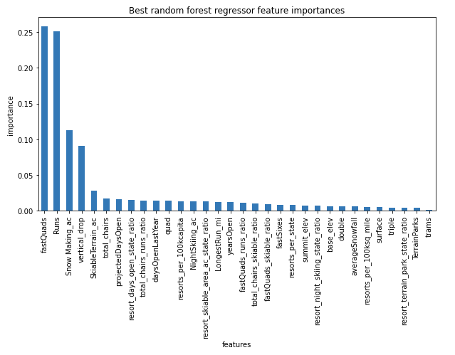

Figure

# Our Recommendation

Big Mountain ski resort currently charges $81 per adult weekend ski lift ticket. With its current facilities, our model predicts that the current features would support a ticket price of $95.87. Even with accounting for the expected mean absolute error of $10.39, Big Mountain could justifiably increase ticket prices by $4.48, to $85.48. We looked at where Big Mountain stood against other resorts in the data set with regards to the important features mentioned above, and it came in at or near the top across the board, which helps justify a higher ticket price. We then used our model to evaluate revenue change based on a few scenarios, that were based off our findings. The first one included closing the least used runs and ski lifts. We wanted to see if there was room to reduce operating costs with minimal loss of ticket value, or potentially bringing the predicted ticket price value closer to current prices. We based the projected revenue off of the assumption of an average of 350,000 visitors per year each buying an average of 5 tickets. Line plots of the change in ticket price value and total revenue are plotted below, in **Figure 3.** What is worth noting here is when closing 3, 4 or 5 runs, there is zero change in ticket value and revenue. In other words, if you were to look for cutting operational costs and decide 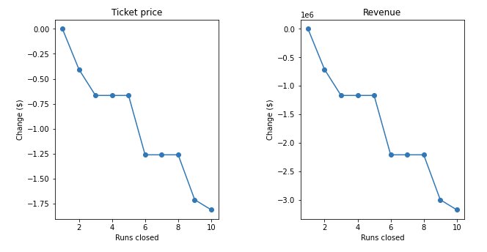to close a few runs, if you close three, you might as well close two more.

Figure

In scenario two, we decided to add a run, increase vertical drop by 150 feet and install an additional chair lift. Running the same assumptions as before to calculate predicted revenue, this scenario increased support for ticket price by $8.61 and annual revenue by $15,065,471. So, depending on the capital cost of implementing these changes, this could be a way to increase revenue. Scenario three replicated scenario two, but also added 2 acres of snow making. This saw negligible change in ticket price support, predicting $9.90 increased support. Scenario 4, as well, saw little to no change, and included increasing the longest run by 0.2 miles and adding its estimated snow coverage of 4 acres.

In short, our recommendation is to evaluate the capital cost increases/reductions of the first two scenarios are whether they would be beneficial for you to implement.